Supplementary data

Table 1 Primers used in this study.
Genes | Primers for real-time RT-PCR
BnACTIN | Forward: 5'-ACGAGCTACCTGACGGACAAG-3'  Reverse: 5'-GAGCGACGGCTGGAAGAGTA-3'
BnaC9.SMG7b | Forward: 5'-CCCTGGAATTGCTGACCGTA-3'  Reverse: 5'-TGGAAAGTGCTGAGGGATGC-3'
BnARF18 | Forward: 5'-GTGAACAAGTATATGGAAGCTAT-3'  Reverse: 5'-CTGTTGTTGGCTCATCCCAT-3'
BnLCR | Forward: 5'-AAGGAGGTTTAAGGGATATGAGA-3'  Reverse: 5'-CTACAAAATGGATTCGAGGACTC-3'
BnCLV3 | Forward: 5'-ATGGGTTGGTTTAACAAGATCTT-3'  Reverse: 5'-TTAAACCGGGAATCTACCGGTC-3'
BnDA1 | Forward: 5'-ACGAGCTACCTGACGGACAAG-3'  Reverse: 5'-GAGCGACGGCTGGAAGAGTA-3'

Table 2 Means of agronomic traits of contrasting NUtE oilseed rape genotypes in the field and pot-culture experiments.
 | Plant height  (cm) |  | Stem diameter  (mm) |  | First valid branch height  (cm) |  | Number of first valid branches
 | Field experiment | Pot experiment | Field experiment | Pot experiment | Field experiment | Pot experiment | Field experiment | Pot experiment
Nt-responder | 149.7 a | 132.1 a | 9.2 a | 10.6 a | 31.5 a | 25.9 b | 9.2 a | 7.1 a
Nt-nonresponder | 148.5 a | 141.7 a | 9.1 a | 10.1 a | 33.2 a | 43.7 a | 9.5 a | 7.1 a
Nt-efficiency | 136.6 a | 144.3 a | 9.3 a | 9.5 a | 27.8 a | 41.4 a | 8.1 a | 5.5 a
Nt-inefficiency | 130.9 a | 138.0 a | 9.1 a | 8.8 a | 27.2 a | 36.2 a | 7.9 a | 5.7 a
Means in a column followed by different letters indicate significant differences according to ANOVA-protected LSD_{0.05} test.

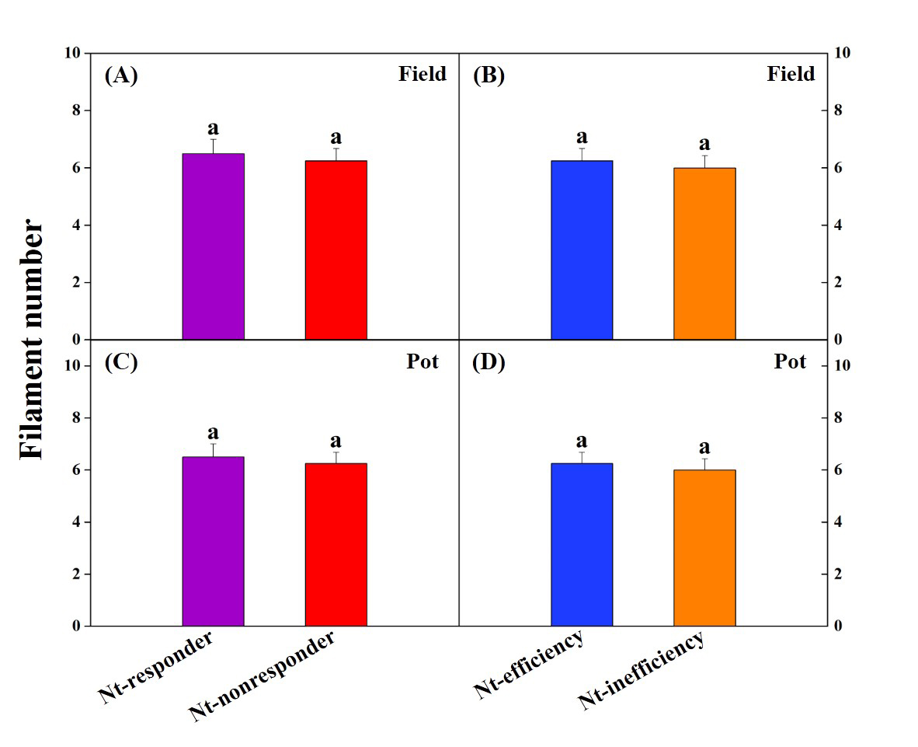
Fig.1 Filament number under field and pot experiments. Each bar represented a mean plus SE of four biological replicates, and different letters above the bars indicate significant differences according to ANOVA-protected LSD_{0.05} test.

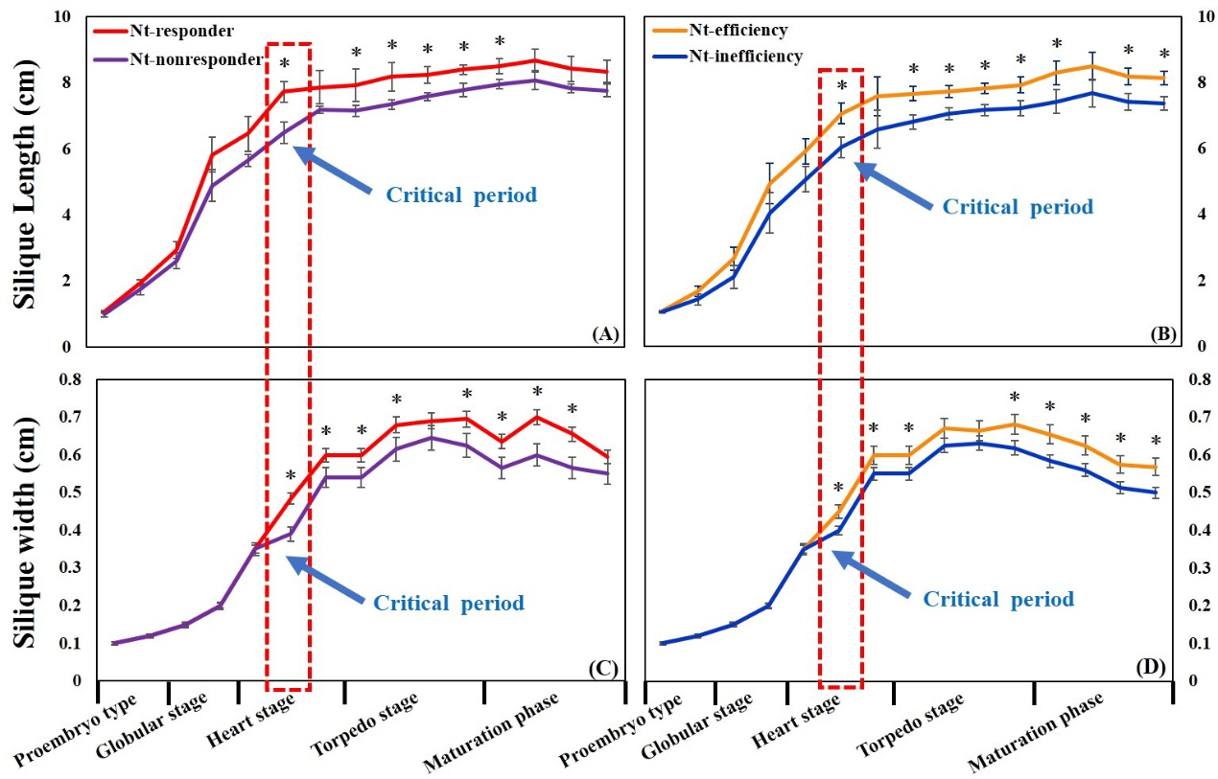
Fig.2 Silique length (A and B) and width (C and D) at proembryo, globular, heart, torpedo and maturation stages in a pot experiment. * indicates significant difference among contrasting NUtE genotypes (P < 0.05). The red frame indicate the initial critical period when the significance difference in silique indexes occurred.

